The FLCC Fall Small - Small Boat Race
Saturday, October 29

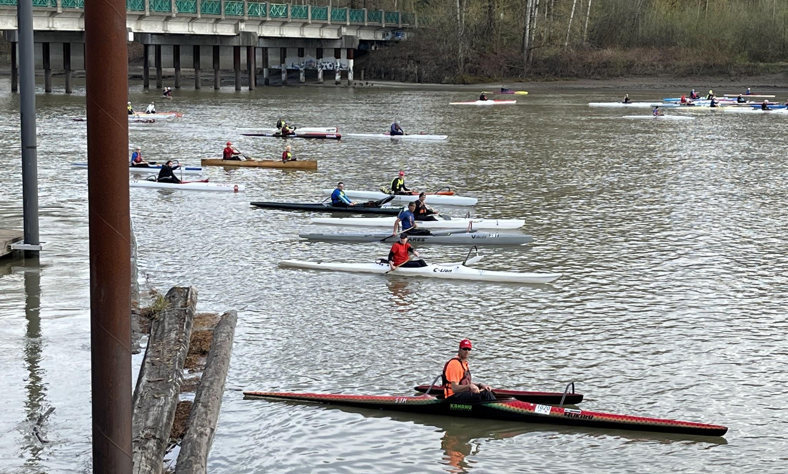

Get your heart pumping and your stroke pace up and conquer the chills. The spectacular golden colours of the fall season offer a crisp setting for your race in Fort Langley BC. This is a fast paced 10-12 Kilometre loop up the Fraser and around Brae Island. It may be your last chance this year to post your best PB or seek to do it under a gruelling 55 minutes (the likely win zone). The Fraser is at its most pleasant and welcoming stage with flow and currents at its calmest and a day that comes with a sweet tidal situation - high tide at slackish. Extend your training for a few more weeks, add that toque to your gear, and top off your year of fun racing with the golden leaves of fall cheering you on.

REGISTER NOW or register on Race Day (for the fair weather types)

- 10-12 km CORA race for small boats circumnavigating the Brae Island
- Small boats include:
  - CORA Types - OC1 / OC2 / OC 3 / / V1 / SUP / Surfski 1 / Surfski 2
  - Non CORA - K1 / K2 / C1 / C2 / Marathon Canoe
- Parking and boat Launch - Brae Island Regional Park
- All Ages & Categories
- $20 Adult / $10 (19 and under)
- Door Prizes for all - we will try!
- Race Day
  - 8:00 Registration
  - 9:15 Pre Race Meeting
  - 10:00 Race
  - 11:45 ish awards / gifts (door prizes)
- Registration Requirements
  - An annual or single day CORA membership. Complete it online.
  - A signed waiver at registration
  - A small boat
  - A paddle
  - A confident capacity to recover - though three safety boats will be about.
  - An approved PFD - on you or near you.
  - Of course, a big smile and maybe a sweater or a rain jacket!

Questions: Ask Jim - smallboats@fortlangleycanoeclub.ca

REGISTER NOW - https://www.fortlangleycanoeclub.ca/product/flcc-fall-small/

